Enterprise Network

Lab 1: Basic Ethernet and IP Networking

# The Starting Topology

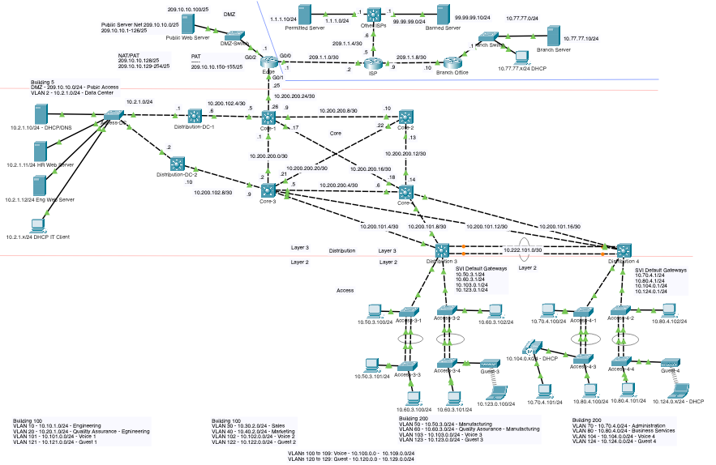

In this lab you will begin with a startup Packet Tracer topology as shown above. The dashed rectangle shows the area of the network where you will create two additional LANs:

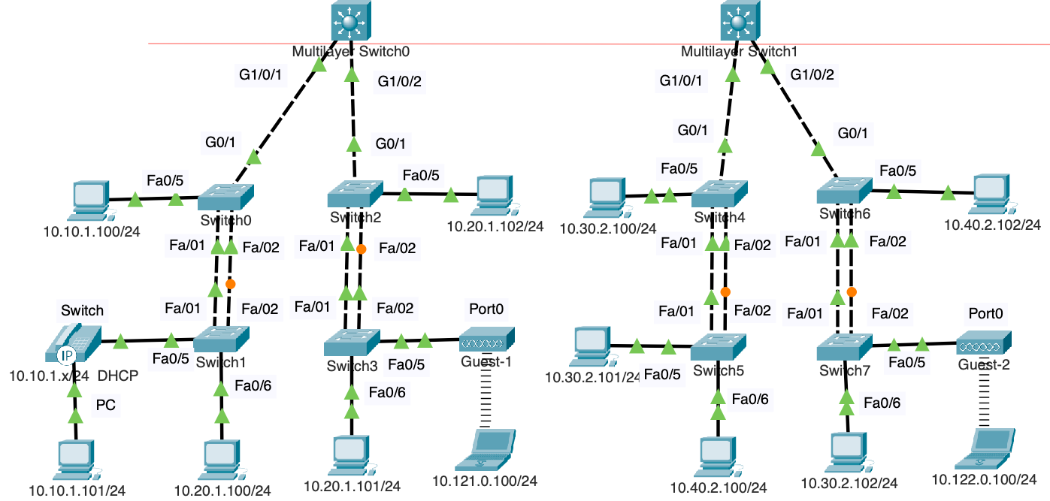

Since we are focusing on basic Ethernet and IP addressing, we’ll go through these initial steps:

1. **Device Setup**:
   * Add the specified devices to the Packet Tracer topology.
   * Assign power supplies to multilayer switches and the IP phone.
2. **Cabling**:
   * Connect devices using the provided cabling instructions.
   * Confirm that no interfaces show red link lights.
3. **IP Addressing**:
   * Assign IP addresses, subnet masks, and default gateways based on the table.
4. **Verification**:
   * Ensure devices can ping their default gateways and other devices in the same IP network.

# Device Setup

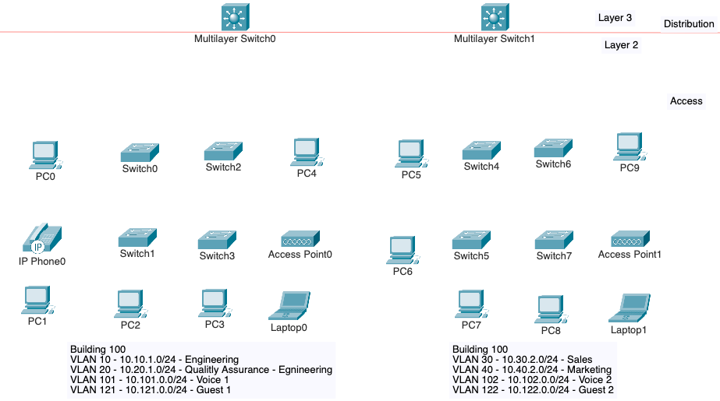

|  |  |  |  |
| --- | --- | --- | --- |
| **Number of devices** | **Device Type** | **Item Name or Model** | **Default Display Name**  **(yours may vary)** |
| 8 | Network Devices/Switches | 2960 | Switch0 through Switch7 |
| 2 | Network Devices/Switches | 3650 (not 3560) | Multilayer Switch0 and Multilayer Switch1 |
|  |  |  |  |
| 10 | End Devices | PC | PC0 through PC9 |
| 2 | End Device | Laptop | Laptop0 and Laptop1 |
| 1 | End Device | IP Phone | IP Phone0 |

Using the diagram, add the devices listed in the table to the workspace. Position the devices according to the diagram provided, ensuring that multilayer switches (3650) are at the top (Layer 3), with access switches (2960) and PCs or other devices below them. Position the multilayer switches just above the red line. These will be distribution layer devices that will be explained more later. Note that the default display names, such as PC0 or Switch0, may vary; ensure they align with the intended topology.

# Adding Power Supplies to Selected Devices

Some devices such as the multilayer switches and IP Phones need to have power supplies installed before the devices can be operational.

## Multilayer Switches

At the **Physical** tab, drag-and-drop **AC-Power-Supply** for BOTH Multilayer Switches.

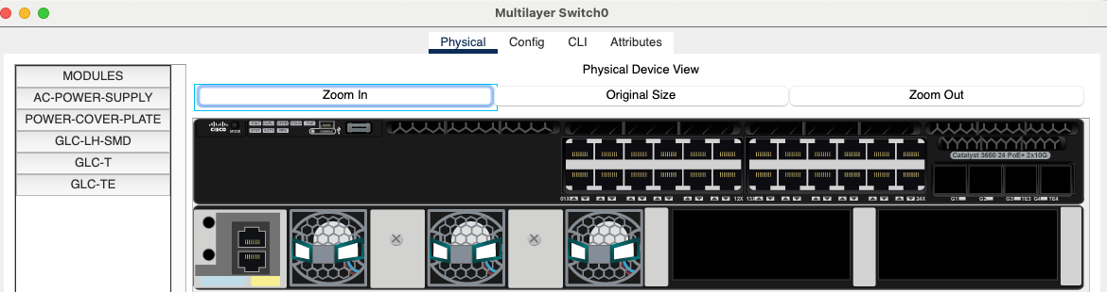

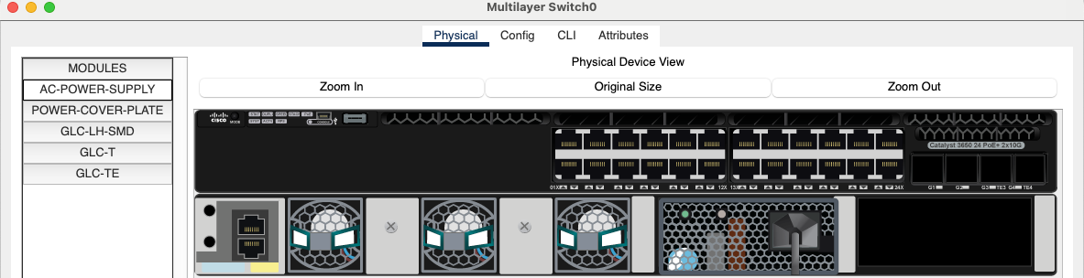

## IP Phone

At the **Physical** tab, drag-and-drop **IP_PHONE_POWER_ADAPTER** for the IP Phone.

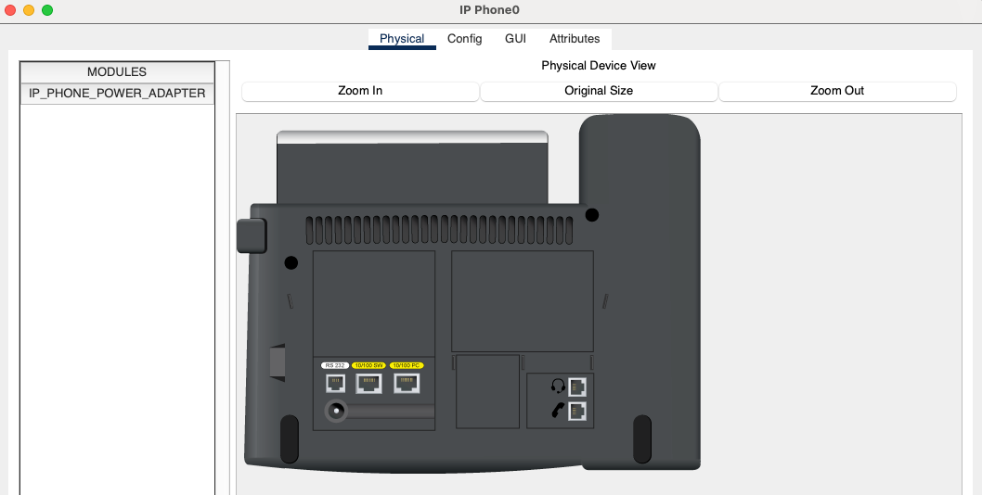

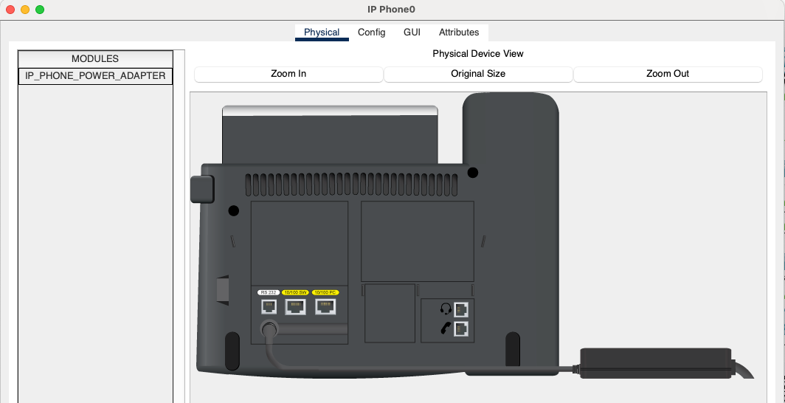

# Cabling

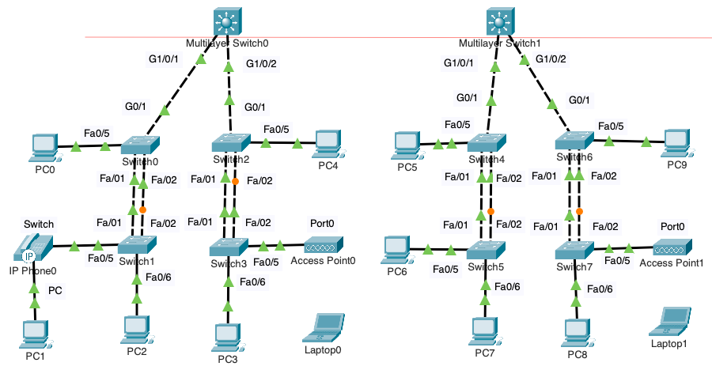

|  |  |  |  |  |
| --- | --- | --- | --- | --- |
| **From Device** | **From Port** | **Cable Type** | **To Device** | **To Port** |
| **PCs (left side)** | | | | |
| PC0 | FastEthernet | Copper Straight-Through | Switch0 | Fa0/5 |
| PC1 | FastEthernet | Copper Straight-Through | IP Phone0 | PC |
| PC2 | FastEthernet | Copper Straight-Through | Switch1 | Fa0/6 |
| PC3 | FastEthernet | Copper Straight-Through | Switch3 | Fa0/6 |
| PC4 | FastEthernet | Copper Straight-Through | Switch2 | Fa0/5 |
| PC5 | FastEthernet | Copper Straight-Through | Switch4 | Fa0/5 |
| PC6 | FastEthernet | Copper Straight-Through | Switch5 | Fa0/5 |
| PC7 | FastEthernet | Copper Straight-Through | Switch5 | Fa0/6 |
| PC8 | FastEthernet | Copper Straight-Through | Switch7 | Fa0/6 |
| PC9 | FastEthernet | Copper Straight-Through | Switch6 | Fa0/5 |
| **IP Phone and Access Points** | | | | |
| IP Phone0 | Switch | Copper Straight-Through | Switch1 | Fa0/5 |
| Access Point0 | Port0 | Copper Straight-Through | Switch3 | Fa0/5 |
| Access Point1 | Port0 | Copper Straight-Through | Switch7 | Fa0/5 |
| **Multilayer Switch to Access Switch** | | | | |
| MLS0 | G1/0/1 | Copper Cross-Over | Switch0 | G0/1 |
| MLS0 | G1/0/2 | Copper Cross-Over | Switch2 | G0/1 |
| MLS1 | G1/0/1 | Copper Cross-Over | Switch4 | G0/1 |
| MLS1 | G1/0/2 | Copper Cross-Over | Switch6 | G0/1 |
| **Access Switch to Access Switch** | | | | |
| Switch0 | Fa0/1 | Copper Cross-Over | Switch1 | Fa0/1 |
| Switch0 | Fa0/2 | Copper Cross-Over | Switch1 | Fa0/2 |
|  |  |  |  |  |
| Switch2 | Fa0/1 | Copper Cross-Over | Switch3 | Fa0/1 |
| Switch2 | Fa0/2 | Copper Cross-Over | Switch3 | Fa0/2 |
|  |  |  |  |  |
| Switch4 | Fa0/1 | Copper Cross-Over | Switch5 | Fa0/1 |
| Switch4 | Fa0/2 | Copper Cross-Over | Switch5 | Fa0/2 |
|  |  |  |  |  |
| Switch6 | Fa0/1 | Copper Cross-Over | Switch7 | Fa0/1 |
| Switch6 | Fa0/2 | Copper Cross-Over | Switch7 | Fa0/2 |

Using the diagram and table provided, carefully connect the devices with the specified cable types and ensure you use the correct port numbers for each connection. Pay close attention to the cabling details, as we will refer to these specific port numbers in future labs. The diagram includes port numbers displayed as "Notes" for your convenience, which is an option you can enable in Packet Tracer to help organize your topology. Be meticulous with your connections to avoid problems in later labs. Details matter!

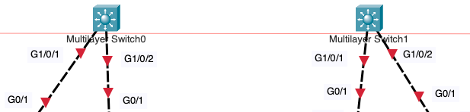 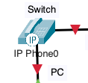

**Note**: If you see red link-lights on the Multilayer Switches or IP Phone, you most likely forgot to install the power supply on the connected interfaces.

# Configuring IP addressing

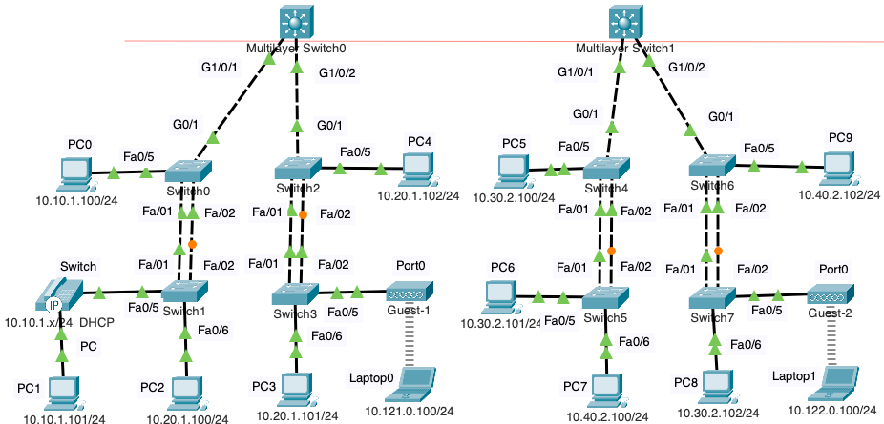

|  |  |  |  |  |
| --- | --- | --- | --- | --- |
| **Device** | **IPv4 Address /**  **Display Name** | **IPv4 Network** | **Default Gateway** | **DNS Server** |
| **Left-side of topology** | | | | |
| PC0 | 10.10.1.100/24 | 10.10.1.0/24 | 10.10.1.1 | 10.2.1.10 |
| PC1 | 10.10.1.101/24 | 10.10.1.0/24 | 10.10.1.1 | 10.2.1.10 |
| PC2 | 10.20.1.100/24 | 10.20.1.0/24 | 10.20.1.1 | 10.2.1.10 |
| PC3 | 10.20.1.101/24 | 10.20.1.0/24 | 10.20.1.1 | 10.2.1.10 |
| PC4 | 10.20.1.102/24 | 10.20.1.0/24 | 10.20.1.1 | 10.2.1.10 |
| **Right-side of topology** | | | | |
| PC5 | 10.30.2.100/24 | 10.30.2.0/24 | 10.30.2.1 | 10.2.1.10 |
| PC6 | 10.30.2.101/24 | 10.30.2.0/24 | 10.30.2.1 | 10.2.1.10 |
| PC7 | 10.40.2.100/24 | 10.40.2.0/24 | 10.40.2.1 | 10.2.1.10 |
| PC8 | 10.30.2.102/24 | 10.30.2.0/24 | 10.30.2.1 | 10.2.1.10 |
| PC9 | 10.40.2.102/24 | 10.40.2.0/24 | 10.40.2.1 | 10.2.1.10 |
| **IP Phone and Laptops** | | | | |
| IP Phone0 | 10.10.1.x/24 DHCP | N/A | N/A | N/A |
| Laptop0 | 10.121.0.100/24 | 10.121.0.0/24 | 10.121.0.1 | 10.2.1.10 |
| Laptop1 | 10.122.0.100/24 | 10.122.0.0/24 | 10.122.0.1 | 10.2.1.10 |

In this section, you will manually configure IPv4 addressing for all end devices in the topology. Accurate IP configuration is crucial for ensuring devices can communicate within their subnets and with other networks. This step highlights the importance of precise configurations, which is why most client devices use DHCP to automate this process—a topic we will explore in a later lab.

The display names have been changed to reflect the IPv4 address of each device. An additional note has been added to indicate the original display name,

**Note**: The IP Phone0 will not be statically configured with IPv4 addressing in this lab. The IP Phone0 will obtain its addressing using DHCP in a later lab.

Below is a breakdown of the subnets and the devices (original device names) in each:

* **Subnet 10.10.1.0/24 (Engineering)**:
  + Devices: PC0, PC1, IP Phone0 (via DHCP).
* **Subnet 10.20.1.0/24 (Quality Assurance - Engineering)**:
  + Devices: PC2, PC3, PC4.
* **Subnet 10.30.2.0/24 (Sales)**:
  + Devices: PC5, PC6, PC8.
* **Subnet 10.40.2.0/24 (Marketing)**:
  + Devices: PC7, PC9.
* **Subnet 10.121.0.0/24 (Guest 1)**:
  + Devices: Laptop0.
* **Subnet 10.122.0.0/24 (Guest 2)**:
  + Devices: Laptop1.

As you proceed, double-check each IP address, subnet mask, default gateway, and DNS server configuration to avoid issues during verification.

**Note**: Although the devices have been configured with an IPv4 address for a default gateway, there is currently no router (default gateway) that has been configured for these networks.

Here is an example for the IPv4 addressing PC0, 10.10.10/24

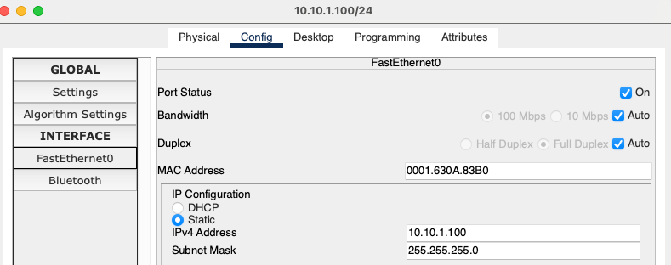

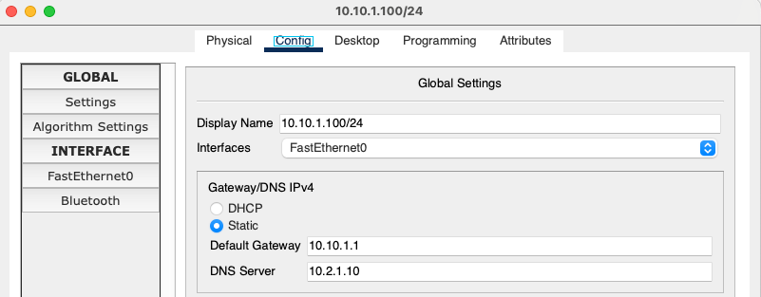

# Wireless LAN (WLAN) Access Points and Laptops

## Access Point SSIDs

Configuring SSIDs (Service Set Identifiers) on access points is essential to define and identify specific wireless networks for devices to connect. Each SSID represents a unique network, allowing users to distinguish between different wireless environments, such as "Guest-1" and "Guest-2" in this topology. Proper SSID configuration ensures devices connect to the intended network and facilitates better network management and security.

Modify the Display Name and the SSID for each Wireless Access Point.

For **Access Point0**, change the display name and SSID to **Guest-1**

 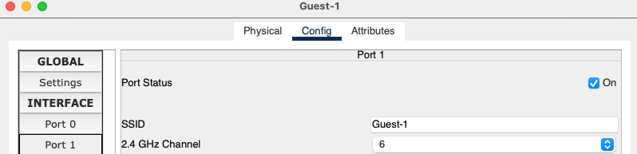

For **Access Point1**, change the display name and SSID to **Guest-2**

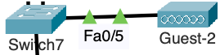

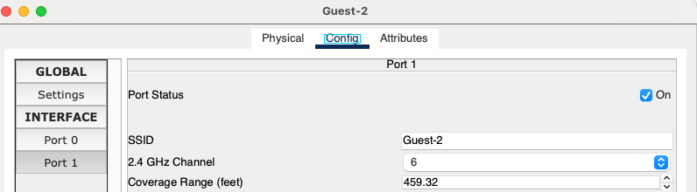

## Laptops

### Install the WLAN NIC

In this part of the lab, the laptops need to have their wired Ethernet NIC replaced with a wireless NIC to connect to the wireless network. While most real-world laptops come equipped with both wired and wireless NICs, Packet Tracer supports only one LAN NIC at a time. To complete this process, the laptop must first be powered off, the wired NIC removed, and the wireless NIC installed. After installation, the laptop must be powered back on for the changes to take effect. Ensure this procedure is followed correctly to avoid connectivity issues.

Remove the Ethernet NICs from the laptops and install WLAN NICs.

**Step 1:** Power-Off

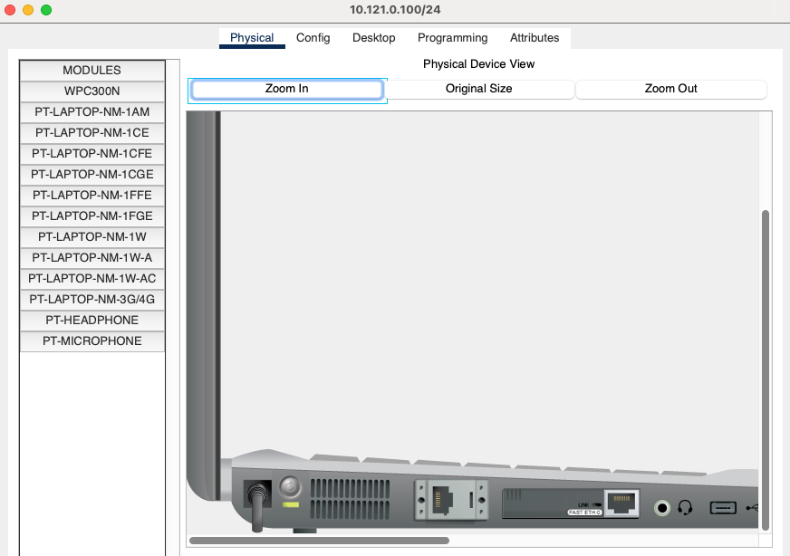

**Step 2:** Remove Ethernet NIC

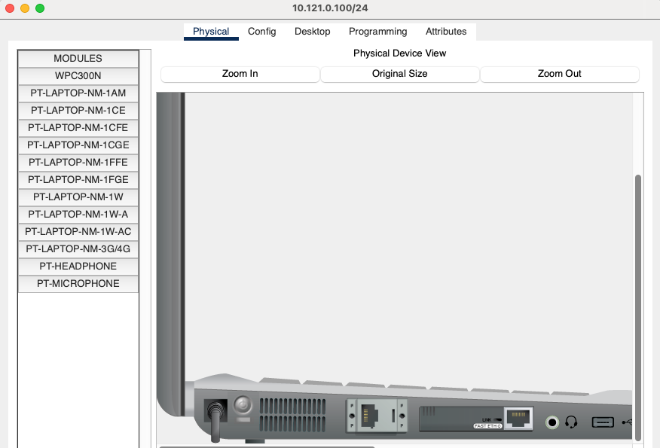

**Step 3:** Install PT-LAPTOP-NM-1-W-AC

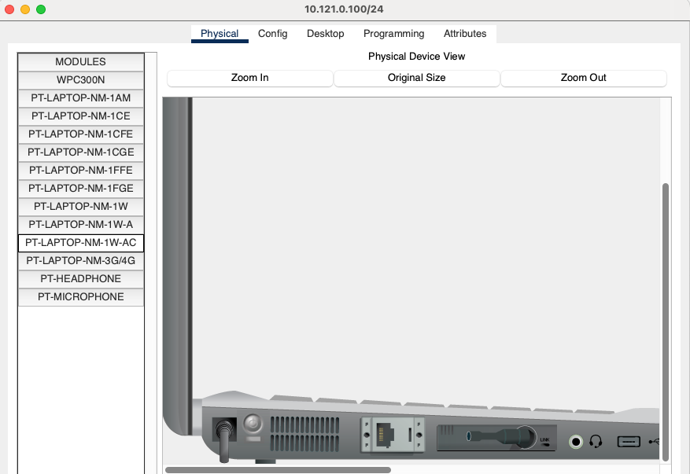

**Step 4:** Power-On

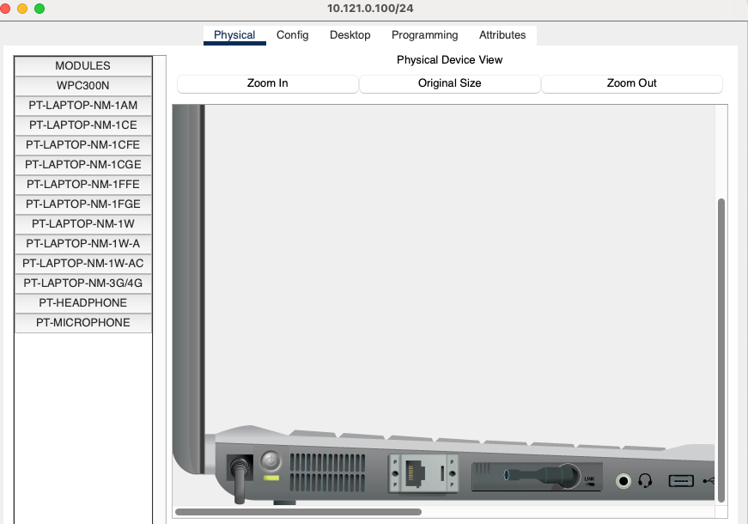

## Configure the SSID on each Laptop

To connect the laptops to their respective wireless networks, configure each laptop to match the SSID of its corresponding access point (Guest-1 or Guest-2). Once the correct SSID is entered, the laptops will associate with their designated access points, as indicated by the established Wi-Fi link. While authentication settings such as WPA-PSK can be configured to enhance security, this is outside the scope of this lab and will not be required. Ensure the SSIDs are entered accurately to establish connectivity.

Enter the correct SSID (Guest-1 or Guest-2)

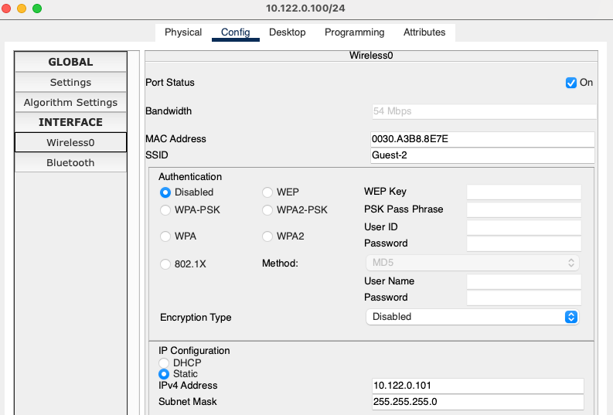

After the SSID is successfully configured, the laptops should now “associate” with their respective access points:

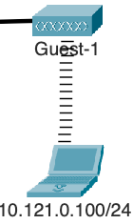 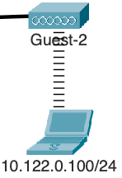

## Configure IPv4 Addressing on each Laptop

Now configure static IPv4 addressing on both laptops. For each laptop, enter the assigned IP address, subnet mask, default gateway, and DNS server as shown in the table. Navigate to the laptop's settings and select the "Static" option under the IPv4 configuration. Ensure that the values match the correct subnet and gateway for each laptop to enable proper communication within the network. Double-check your entries for accuracy before proceeding.

Configure the IPv4 address, subnet mask, default gateway, DNS server and display name for BOTH laptops.

Example Laptop0 – 10.121.0.100/24

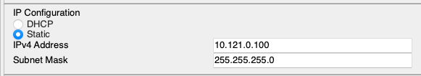

Select **Global > Settings** to configure the default gateway and DNS server addresses**:**

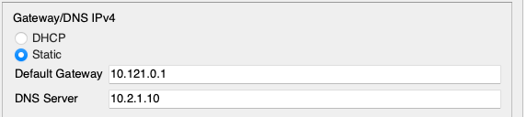

|  |  |  |  |  |
| --- | --- | --- | --- | --- |
| **Device** | **IPv4 Address /**  **Display Name** | **IPv4 Network** | **Default Gateway** | **DNS Server** |
| Laptop0 | 10.121.0.100/24 | 10.121.0.0/24 | 10.121.0.1 | 10.2.1.10 |
| Laptop1 | 10.122.0.100/24 | 10.122.0.0/24 | 10.122.0.1 | 10.2.1.10 |

# Examining our topology

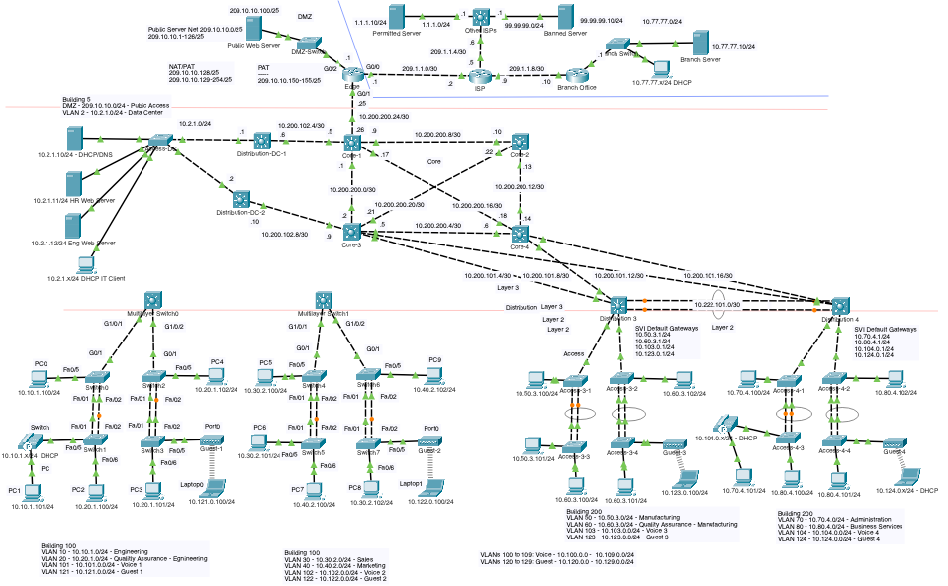



**How many broadcast domains did we create?**

There are two broadcast domains in this topology—one for the devices connected to Multilayer Switch0 and one for the devices connected to Multilayer Switch1. All devices within a broadcast domain can communicate directly at Layer 2, but devices in different broadcast domains require a Layer 3 device for communication.

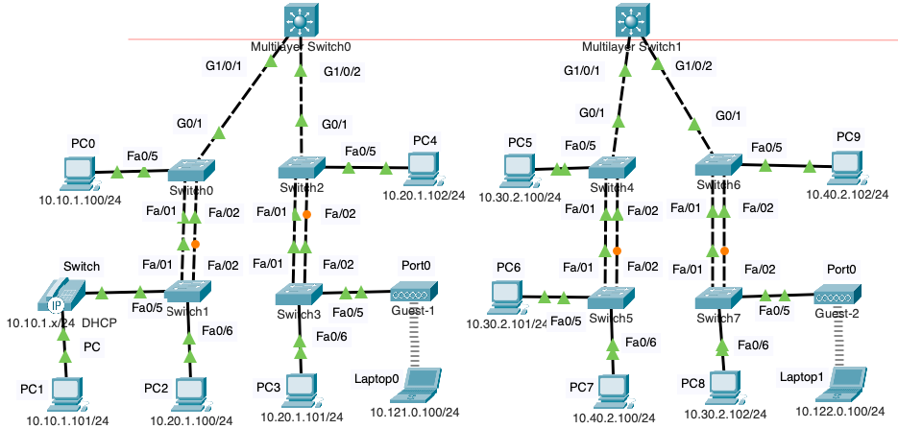

**Verify devices on the same IP network can ping. For example, PC2 – 10.20.1.100/24 can ping PC3 – 10.20.1.101/24**

Cisco Packet Tracer PC Command Line 1.0

C:\>**ping 10.20.1.101**

Pinging 10.20.1.101 with 32 bytes of data:

Reply from 10.20.1.101: bytes=32 time<1ms TTL=128

Reply from 10.20.1.101: bytes=32 time=1ms TTL=128

Reply from 10.20.1.101: bytes=32 time<1ms TTL=128

Reply from 10.20.1.101: bytes=32 time<1ms TTL=128

Ping statistics for 10.20.1.101:

Packets: Sent = 4, Received = 4, Lost = 0 (0% loss),

Approximate round trip times in milli-seconds:

Minimum = 0ms, Maximum = 1ms, Average = 0ms

C:\>

Devices within the same IP network, such as PC2 (10.20.1.100/24) and PC3 (10.20.1.101/24), should successfully ping each other. This demonstrates that they are in the same broadcast domain and IP subnet, allowing them to communicate without requiring a router.

**Verify devices on different IP networks cannot successfully ping. For example, PC0 – 10.10.1.100/24 cannot successfully ping PC3 – 10.20.1.101/24**

Cisco Packet Tracer PC Command Line 1.0

C:\>**ping 10.20.1.101**

Pinging 10.20.1.101 with 32 bytes of data:

Request timed out.

Request timed out.

Request timed out.

Request timed out.

Ping statistics for 10.20.1.101:

Packets: Sent = 4, Received = 0, Lost = 4 (100% loss),

C:\>

Devices on different IP networks, such as PC0 (10.10.1.100/24) and PC3 (10.20.1.101/24), will not successfully ping each other. This is because devices in different subnets require a router or a multilayer switch with routing enabled to facilitate communication.

**When any device sends an ARP Request, an Ethernet broadcast, which other devices will receive the broadcast?**

An ARP Request is sent as an Ethernet broadcast, so all devices within the same broadcast domain will receive it. However, only the device with the matching IP address will respond. Devices in different broadcast domains will not receive the ARP Request.

**Examine the MAC address table on any of the switches.**

Switch>**show mac address-table**

Mac Address Table

-------------------------------------------

Vlan Mac Address Type Ports

---- ----------- -------- -----

1 0001.630a.83b0 DYNAMIC Fa0/5

1 0001.96e8.0801 DYNAMIC Fa0/1

1 0001.96e8.0802 DYNAMIC Fa0/2

1 0060.7096.e001 DYNAMIC Gig0/1

Switch>

Currently, all switch ports are part of VLAN 1, meaning all devices are in the same broadcast domain. You can verify this by examining the MAC address table, which lists the MAC addresses learned on each port. In future labs, you will configure VLANs to segment the network into multiple broadcast domains, improving performance, scalability, and security.

**Can any device ping the either of the laptops?**

No, the laptops (10.121.0.100/24 and 10.122.0.100/24) are on separate subnets that are not connected to a router or a routing-enabled switch. Without a Layer 3 device, devices in different subnets cannot communicate.

**Why are some of the link lights amber?**

The amber link lights indicate that Spanning Tree Protocol (STP) has placed certain ports into a blocking state to prevent network loops. This is a normal behavior in redundant network topologies. In later labs, you will explore technologies like EtherChannel to bundle links and avoid loops while maintaining redundancy.

**What would we need for device in different networks to communicate?**

Devices in different networks require a router or a multilayer switch with routing enabled. The router must have interfaces configured with IP addresses corresponding to the default gateways of each network to facilitate inter-subnet communication.

**What would we need for the two physically separate LANs to communicate?**

To enable communication between the two physically separate LANs, you need a direct physical connection between Multilayer Switch0 and Multilayer Switch1. This connection will allow routing or Layer 2 switching/bridging to occur, as configured in later labs.

**Is there a disadvantage to have devices in different networks in the same broadcast domains?**

Yes, having devices in different networks within the same broadcast domain can cause performance degradation due to excessive broadcast traffic, limit scalability as the network grows, and introduce security risks since traffic is not segmented. Configuring VLANs will address these issues by isolating broadcast traffic and improving overall network efficiency.